Commanding Officer’s Tool Kit

Deployability Assessment and Assignment Program
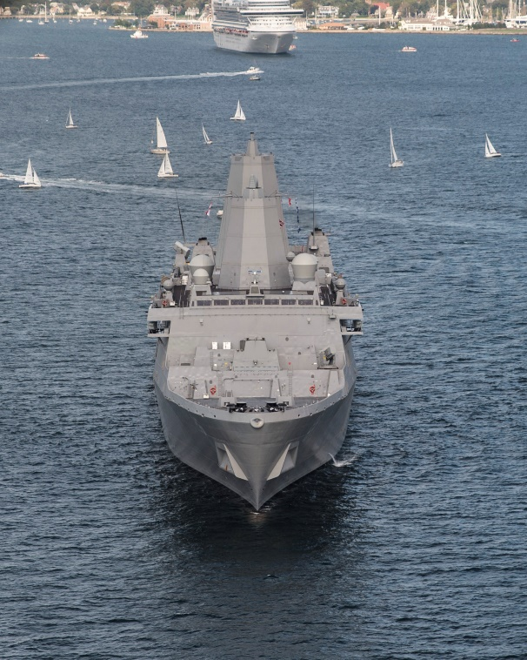
Why was the program established?
Navy formalized the program in OPNAVINST 1300.20 to ensure the timely disposition, processing and accountability of Service members who are either medically or administratively limited from deployment. It aligns to the objectives of DoD Instruction (DoDI) 1332.45, Retention Determinations for Non-Deployable Service Members, released earlier this summer to maximize the lethality and readiness of the joint force.

Who runs the program?

The Deputy Chief of Naval Personnel (DCNP) is the single process owner for Total Force. Assistant Commander, Navy Personnel Command for Career Management (PERS-4) is the Active Component (AC) and Full Time Support (FTS) Program Manager. Deputy Commander, Navy Reserve Force is the Selected Reserve (SELRES) Program Manager.

Who is affected by the policy?
The policy applies to all Navy AC, FTS and SELRES personnel, commands and activities. All Sailors are expected to be deployable.

What is deployability and how is it assessed?

A Service member is deployable if he or she does not have a Service-determined reason that precludes him or her from deployment. The Military Treatment Facility (MTF) and the Sailor’s command will make deployability assessments by determining the Sailor’s ability to perform appropriate military duties commensurate with his or her office, grade, rank and skill in light of ongoing medical treatment or administrative limitations. (See Medical Non-Deployability Determination Process flowcharts and the end of this toolkit)

How does the Navy benefit?
Accurate and timely identification and classification of Sailors with deployment-limiting conditions is critical to determining overall personnel readiness and effectively manning the fleet.

Command and Sailor Responsibilities

Command Responsibilities
Overall personnel readiness must be a priority of command leadership as it directly impacts force lethality. Commands must:

- Designate, in writing, a deployability coordinator to work in concert with MTF deployability coordinators to report and track medically limited Sailors.

- Ensure timely and accurate activity classification code assignments for officers and enlisted Service members assigned. Navy Reserve Activities (NRA) will ensure proper manpower availability status (MAS) codes are documented.

- Ensure annual physical health assessment (PHA) completion and accurate individual medical readiness (IMR) reporting of all personnel assigned.

- Ensure command fitness leaders comply with OPNAVINST 6110.1J as it pertains to deployability status. Any Sailor who is waived from any portion of the semi-annual PFA must be placed in the appropriate medically limited status.

- Monitor Sailors in temporary or permanently non-deployable status and coordinated closely with their respective command career counselors on issues of expiration of soft end of active obligated service (S-EAOS) or mandatory separation while on temporary limited duty (TLD) or in the disability evaluation system (DES). Contact the cognizant enlisted community manager for guidance concerning Sailors with an expired S-EAOS or mandatory separation date during a period of TLD or DES. NRAs will monitor for SELRES personnel.

Issue Administrative Remarks (NAVPERS 1070/613) to all TLD Service members acknowledging the responsibility to report to all scheduled appointments and to be compliant with medical recommendations and limitations. The issued Administrative Remarks should note that failure to report to scheduled appointments may constitute a violation of the Uniform Code of Military Justice (UCMJ), article 86 (failure to go to appointed place of duty) and article 92 (failure to obey a lawful order).

Use written counseling and fitness reports or performance evaluations to document a Service member’s failure to maintain medical readiness by design or neglect or comply with responsibilities to maintain individual readiness (e.g., repeatedly failing to complete required PHA actions). MILPERSMAN 1610-015 and a BUPERS 1610.10D update provide additional guidance.

Initiate administrative separation processing or work with medical to refer to the DES, as appropriate, once the command determines that there is a reasonable expectation that the restriction will not be resolved and the Service member will not become deployable within 12 months. For Sailors referred to the DES, the command must provide clear and candid input via the Non-Medical Assessment (NMA) regarding the Sailor’s ability to perform the full spectrum of the duties of their office, grade, rank and rating. This must take into consideration his or her ability to perform not only during a shore tour, but also their occupational requirements for a sea tour.

Sailor Responsibilities

It is the personal responsibility of every Service member to maintain individual readiness and deployability. Sailors must:

Ensure personal accountability in all aspects of individual readiness, including medical, dental, physical and administrative (e.g. maintaining a family care plan) readiness.

Be compliant with all IMR requirements and ensure documentation is delivered to the MTF (or NRA medical department representative for SELRES), where medical records are maintained for entry into an approved electronic data system as well as in health records. Withholding or failure to include medical documentation in the medical record may result in denial of future disability benefits. IMR consists of individual medical equipment (e.g., eye glasses, warning tags, gas mask inserts, etc.), immunizations, medical readiness laboratory studies, dental readiness, deployment-limiting medical conditions and PHA.

Report to the command deployability coordinator and MTF patient administration office upon being recommended for placement, extension of, or removal from TLD.

If in a restricted deployability category (e.g., TLD or DES), ensure leave (other than emergency) is coordinated with the command deployability coordinator and does not conflict or coincide with medical appointments.

If on TLD, visit with the treating provider on a routine basis throughout the TLD period and ensure a medical TLD appointment is scheduled and attended no later than 30 days prior to the expiration of the TLD period.

Monitor IMR via Bureau of Naval Personnel Online (BOL) and complete all IMR requirements in a timely manner.

Questions and Answers

Why is the Navy initiating separations for non-deployable Service members?

The Navy is meeting the objectives of the SECDEF policy to maximize lethality and readiness. Sailors who are determined to be “non-deployable” for greater than 12 consecutive months will be notified of pending administrative separation processing or referral to the Disability Evaluation System, or DES. All Sailors are expected to be deployable, regardless of current duty type (operational or non-operational).
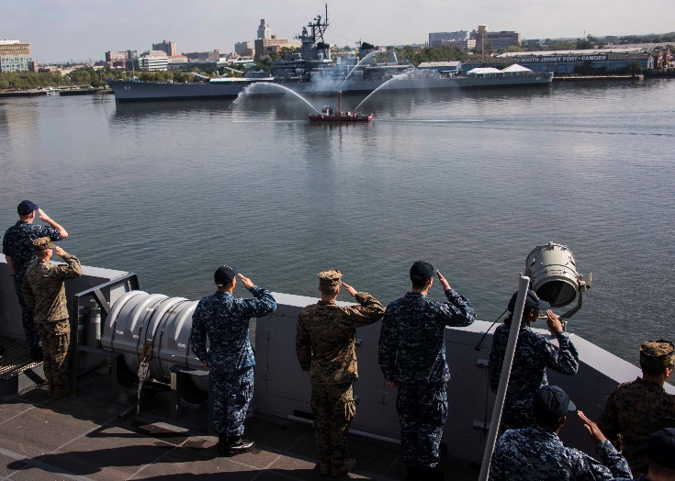

What authority does the Navy have to separate Sailors for non-deployability?

There are no new bases for separation as a result of this policy. Existing authorities are DoD Instruction (DoDI) 1332.14, Enlisted Administrative Separations and MILPERSMAN 1910 (series) for Enlisted Sailors; DoDI 1332.30, Commissioned Officer Administrative Separations and SECNAVINST 1920.6C for officers; and DoDD 1332.18, DES, and SECNAVINST 1850.4E for disability processing.

How many Sailors does this affect?

The deployability of Service members is tracked by the respective AC/FTS and SELRES Deployability Assessment and Assignment Program Managers. The initial number of Sailors impacted will be known after the effective date of October 1, 2018.

What are the deployability assessment codes?

Active Component and Full-Time Support Sailors will be classified according to the following categories: Category 1 - Fully Deployable, Category 2 - Deployable with Limitations, Category 3 - Temporarily Non-Deployable or Category 4 – Permanent Non-Deployable. The SELRES Program Manager will utilize manpower availability status (MAS) codes to classify the varying limitations into categories that designate a Sailor’s ability to mobilize.

Are Sailors considered non-deployable if they are overdue for dental treatments/exams (Dental Class 3 or 4) or physical health assessments?

Sailors who are overdue in these categories may have non-deployable conditions. Sailors are individually responsible for their medical and dental readiness and will be held accountable for completing appointments on time and correcting any IMR issues to ensure they remain ready to deploy. Failure to maintain medical readiness by design or neglect or comply with medical recommendations and limitations is a substantial departure from the expected standards for military bearing/character. A Service member’s failure to meet IMR requirements may be documented in a special evaluation or fitness report and could ultimately result in administrative separation.

Are any Sailors exempt from this policy?

Pregnant and post-partum Sailors are the only members exempt from this policy.

Does the policy apply to Navy Wounded Warrior – Safe Harbor Sailors or those on humanitarian assignment?

These Service members are not exempt but may request retention. The Secretary of the Navy (SECNAV) has specific authority to retain a combat wounded Service member who has been evaluated through the DES and whose reason for non-deployability is a direct result of his or her combat wounds.

Does the policy apply to Sailors close to retirement?

These Sailors are not exempt but may request retention. Unless sooner discharged or retired under another provision of law, or discharged due to misconduct or substandard performance, SECNAV may retain those Sailors who will be non-deployable for 12 months or longer due to administrative reasons and who have attained such years of creditable service so as to be within three years of qualifying for retirement.

How will Sailors be notified if they are impacted by this policy?

Starting October 1, 2018, Sailors who have been non-deployable for 12 consecutive months will be notified via naval message, letter, or email of mandatory processing for administrative separation or referral to the Disability Evaluation System, or DES. From that point forward, notifications will occur on a monthly basis.

What is the Disability Evaluation System, or DES?
The Disability Evaluation System (DES) is the process by which the Physical Evaluation Board (PEB) determines whether the Service member has a medical condition that will prevent him or her from returning to duty status to reasonably perform the duties of office, grade, rank and rating and if the Sailor cannot return, whether the Sailor is recommended for separation or retirement.

If I am in a non-deployable status, how long will it take me to get medical appointments scheduled and will any delays count toward the 12-month timeline?
Access to care will vary at every Military Treatment Facility (MTF) and clinic; however, if initial appointment wait times are greater than 30 days, the Sailor is referred to the civilian network. Each Sailor must be proactive in setting and attending appointments to receive needed care and work toward deployability. If a Sailor experiences delays out of his or her control that directly result in non-deployability greater than 12 months, then this will be considered during the retention determination process. Navy Medicine is proactively realigning resources and focus to fully support Sailor readiness.

Can Sailors be considered for retention beyond 12 consecutive months of non-deployability?
Yes. SECNAV may grant retention on a case-by-case basis if determined to be in the best interest of the Navy.

For what length of time may Sailors be retained?
Retention may be approved for up to the length of time remaining on an enlistment contract or for 3 years for officers. Retention may be renewed upon expiration of the retention period.

What is the process for submitting retention requests?

ADMINISTRATIVE: Sailors who are notified for administrative reasons must personally submit retention requests with command endorsement. A sample retention request will be available at the Navy Personnel Command Deployability website listed at the bottom of this tool kit.
- MEDICAL: No action is required by Sailors who are notified for medical reasons. Instead, the cognizant medical evaluation board may recommend retention on the Sailor’s behalf for an additional, outcome-based period of limited duty if it is likely that the member's deployment-limiting medical condition will improve or resolve to permit a return to deployable status. If a Sailor is referred to the DES and found not fit for duty, the member can then personally submit a retention request to remain in service.

If a Sailor is non-deployable for more than 12 months and is separated, what will be the characterization of the Sailor's discharge (e.g., honorable, other than honorable, etc.)?

Separation under this policy does not change how characterization of discharge is determined.

Will this policy affect Post-9/11 GI Bill eligibility?

In accordance with DoDI 1341.13 Post-9/11 GI Bill (change 1, July 12, 2018), only separations characterized less than "Honorable" impact a Sailor's eligibility for Post 9/11 GI Bill benefits. If a Sailor is discharged with less than 36 months of total service, he or she will be eligible for less than 100% of the benefit.

The real impact could be for dependents who received transferred benefits if the member is discharged before completing their 4-year obligation for transferability. The conditions that allow a family member to retain eligibility are listed in pages 13-15 of the instruction, under the "Failure to Complete Service Agreement" section.

How will this affect retention bonuses?

Specific administrative or medical circumstances determine recoupment of bonuses. Refer to specific policy guidance for the type of bonus in question.

If a Sailor can resolve the underlying cause resulting in the non-deployable status, what action is required to remove them from the non-deployable list?

Once the respective AC/FTS or SELRES program manager is informed by the appropriate authority or Navy system, the member will be classified as deployable and the process for any pending retention determination will be cancelled.

What about Sailors who are “deployable with limitations”?

A Sailor’s deployability will be assessed at each healthcare encounter. Any Sailor determined to have medical, geographic, or platform limitations will be classified as “deployable with limitations.” If assignment to duties commensurate with office, grade, rank, and skill is not possible due to the specified limitations, forced conversion may be appropriate.

How does this policy affect Forward Deployed Naval Force (FDNF) sea duty units (ships, squadrons, etc.)?
The policy applies no differently to FDNF personnel.

What if a Sailor is in a non-deployable status at a non-operational command, with no scheduled deployments?
This policy applies to all Sailors, regardless of current duty type (operational or non-operational). All Service members are expected to be deployable.

For more information regarding deployability, visit the NPC website: http://www.public.navy.mil/bupers-npc/career/LIMDU/Pages/default.aspx
(Toolkit photos by Mass Communication Specialist 1st Class Timothy Wilson)

