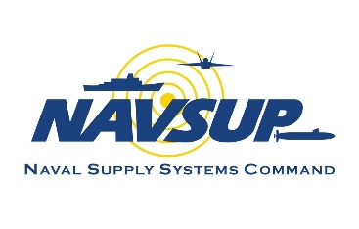
OP Drumbeat
August 2025

Supply Corps Team,

August’s OP Drumbeat covers LT Operational tours, the Executive Development Program, updates to NAVSUP instructions, and an introduction to our newest teammate. Please note important career counselor highlights for OMPF, eDACM, self-nominations, and OPTOUR AQDs. OP would love to hear your ideas! For future Drumbeats, please submit suggestions to the Career Counselor.

LT Operational Tours

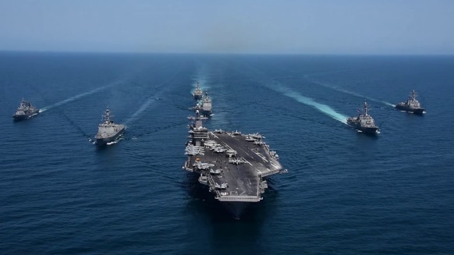
Due to an unprecedented inventory deficit at the LT operational desk, LTs on shore duty with PRDs in CY26 and CY27 will be adjusted to 24 months to mitigate extensions at sea. Most shore duty orders are written for 36 months to comply with DODI 1315.18, but NPC has the authority to detach an officer prior to completion of the 36-month tour for assignment to sea duty. Please contact your detailer with questions and be prepared to negotiate your next assignment based on your new PRD window (8 months CONUS or 10 months OCONUS). Shore duty billets will be advertised for backfills IAW the Officer Manning Plan.

OP encourages officers and commands affected by the PRD shift to continue addressing questions with the LT shore and operational desks. Thank you to everyone for your support as we continue managing inventory shortfalls.

Supply Corps Billet Realignment Initiative (BRI) Update

As we finalize our widescale billet realignment initiative, we are providing an update on where we are today and what to expect moving forward. The Supply Corps (SC) is 97% complete towards aligning Officer Program Authorization (OPA) (or billet base) to our plan through FY27 and remain on track for FY29 completion. Execution is delivering what was promised – billet base realignment, improving promotion flow point, and creating a sustainable Supply Corps where Officers develop requisite skills while maintaining work/life balance to meet career and Navy needs.

The team continues to track community health from every angle as the billet base adjusts, and accessions remain at an all-time high. Overall, these efforts are resulting in inventory improvements. The community in aggregate is healthy, but BRI will drive a temporary increase in the LT deficiency resulting from shore billets rolled down to O3. O3 shore billets will see improved fill rates beginning in FY26 as Year Group 2024 officers begin to rotate to their first shore duty. Increased numbers from Year Groups 2021 and 2022 will mitigate O3 shortfalls at sea.

Pivoting from this large-scale force shaping, we are now focusing on BRI 2.0, highlighting individual SC competencies and working with commands to ensure accurate billet coding. While the first phase of BRI did not damage competencies, we know improvements are needed to ensure long-term sustainability. We look forward to continued teaming with Budget Submitting Offices (BSOs) and commands to ensure SC professional development is aligned to Navy requirements.
Executive Development Program (EDP)

The Executive Development Program (EDP) provides senior SC officers with a short-term training program (one to two weeks) from post-graduate level civilian institutions focused on enhancing leadership skills, innovative and creative thinking, and strategic decision-making capabilities. The program is a strategic investment in our senior officer cadre. Please see NAVSUPINST 1520.6C (Supply Corps Instructions) for eligibility criteria. Officers who do not meet eligibility requirements may submit a written request for exception.

Fall courses are generally unavailable due to Continuing Resolution, which extended into the summer this year due to the government mandated freeze on civilian purchase cards. The ideal time to attend is in the spring or summer months, with five courses generally available. If FY25 fiscal constraints affected your ability to attend, or if you have other questions regarding the program, please contact Mr. Nicholas Alvarez at nicholas.e.alvarez.civ@us.navy.mil or the SC Career Counselor at supply_corps_cc@navy.mil.

NAVSUP Instruction Updates

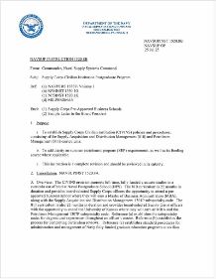
The Chief of Supply Corps recently signed and published updates to the Civilian Institutions (CIVINS) and Training with Industry (TWI) instructions. The instructions are complete revisions and should be reviewed in their entirety. Below are the major highlights:

CIVINS – NAVSUPINST 1520.8B
Officers in the CIVINS program are required to seek local area unfunded internships for their summer enrichment programs (SEP). If no local area SEPs are available, officers will seek an appropriate Navy command, subject to Office of Supply Corps Personnel (OP) approval. In the event a student cannot execute a local area SEP, NAVSUP will fund associated travel, lodging and per diem expenses.

CIVINs officers must submit their SEP plan to the SC Career Counselor for approval. The officer must accomplish one of the functional application programs listed in the instruction in the summer between their first and second years of postgraduate study (Supply Corps Instructions).

TWI – NAVSUPINST 1520.7D
Participants will provide quarterly briefs to the Commander, NAVSUP and designated representatives. At completion of the tour, participants will provide a final report to the Commander, NAVSUP addressing:

- Return on Investment (ROI) to the United States Navy
- ROI to NAVSUP and the SC
- ROI to the individual
- Established relationships between Navy command(s) and TWI company
- Highlight program process improvements - Get Real, Get Better

Participants will receive a “Not Observed” periodic fitness report from the hosting activity or NROTC unit and, upon completion of the TWI Program, will receive a “Not Observed” concurrent fitness report from the Chief of Supply Corps to coincide with a “Not Observed” individual detaching fitness report from the hosting activity or NROTC unit.

Meet the New LT Operational and PG School Detailer

Lieutenant Commander Jake Laird is a native of Greenville, South Carolina. He is a 2011 graduate of the United States Naval Academy and holds a Master of Business Administration from the University of Michigan Ross School of Business.

His operational assignments include Supply Officer, USS Nevada (SSBN 733) and Aviation Support Officer onboard USS Theodore Roosevelt (CVN 71).

Ashore, Lieutenant Commander Laird most recently served as the Sustainment Branch Chief at U.S. Africa Command before assuming duties as Executive Officer to the Director of Logistics. Prior to that, he served as the Assistant Supply Officer, Helicopter Maritime Strike Wing Pacific; as Aide de Camp, NAVSUP Weapon Systems Support; and as the Contracting Officer Representative, U.S. Sixth Fleet.

Orders Release Posture

Based on current funding levels, Navy Personnel Command is releasing orders with an estimated date of departure through November 2025. Please reach out to your detailer if you have questions about pending orders.

Career Counselor Highlights

Official Military Personnel File Download: Official Military Personnel File (OMPF) data will remain online and is fully backed by industry standards. Rumors that Millington Data Center and BOL will shut down due to a contract not being renewed are false. Please disregard advice to download and save OMPF data.

Electronic Defense Acquisition Career Management (eDACM): If recently assigned to an ACQ coded billet, please allow 45-60 days for eDACM to update your personnel and position data automatically via a data feed received from your authoritative manpower system. If this does not occur, reach out to the eDACM support team with questions (eDACM_Support@us.navy.mil).

Subspecialty self-nomination versus acquisition self-nomination: Information included in Fitness Reports matter, especially when submitting a self-nomination package for subspeciality or acquisition experience.

- For subspeciality experience, reference the Education Skills Requirements (ESRs) and Core Skills Requirements (CSRs) to capture your performance accurately. ESRs and CSRs can be found at the following link: https://www.mynavyhr.navy.mil/Career-Management/Education/Subspecialty/
- For acquisition experience, reference the Position Category Descriptions (PCDs) for each acquisition category. The PCDs can be found at the following link: (https://icatalog.dau.edu/onlinecatalog/pcd.aspx)

OPTOUR Additional Qualification Designation (AQDs): Below provides the timeline for award of the various OPTOUR AQDs. Please reach out to the SCCC or your detailer if you are missing an AQD or have questions.

- 928 AQD: Recorded on your official record upon successful completion of your 1st OPTOUR
- 92A AQD: Recorded upon assignment to your 2nd OPTOUR once you report to your new command
- 929 AQD: Recorded upon successful completion of your 2nd OPTOUR

Career Counselor Webpage: The Career Counselor webpage is undergoing a major overhaul. Please remain patient as outdated and defunct links are removed and updated.

Contact Information: Does OP have your current contact information? Update your contact information upon reporting to a new command to ensure you receive critical news and information.

Call or email the Career Counselor with any questions or concerns.

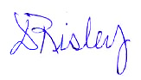

CAPT Dena B. Risley
Director, Supply Corps Personnel
26 August 2024 TEAMs link and dial-in information

Important Links

LT Operational / Question and Answer Session (1400-1500 CDT)
Microsoft Teams Need help?
Join the meeting now
Meeting ID: 993 267 142 27
Passcode: Uw2HC6vi

Dial in by phone
+1 858-980-0000, 457743109# United States, San Diego
Find a local number
Phone conference ID: 457 743 109#

MyNavy HR links:

- Supply Corps Career Counselor

- CAPT Detailer

- CDR Detailer

- LCDR Detailer

- LT Operational & PG School Detailer

- LT & LTJG Detailer

- Internship

- Nominative Billets

- 2025 Supply Corps Directory (CAC-Enabled)

- FY27 Board Schedule

- Officer Retirements / Officer Resignations

- Supply Corps Officer - Training, Education, Qualifications - MyNavy Portal

Contact Us

Position | Name |  | E-mail
Director | CAPT Dena Risley |  | dena.b.risley.mil@us.navy.mil
Director, Detailing Division | CAPT(s) Krysten Ellis |  | krysten.j.ellis.mil@us.navy.mil
OP Assistant | CDR Long Tran |  | long.k.tran.mil@us.navy.mil
OP1 Assistant | LCDR Michelle Coleman |  | michelle.m.coleman11.mil@us.navy.mil
TAR Mgt. Branch Detailer | CDR Treven Feleciano |  | treven.s.feleciano.mil@us.navy.mil
“Pit Boss”/LCDR Detailer | CDR Matt Wall |  | kevin.m.wall10.mil@us.navy.mil
LT Operational/PG School | LCDR Jake Laird |  | jacob.c.laird2.mil@us.navy.mil
LT Shore Detailer | LCDR Winston Lamb |  | winston.c.lamb.mil@us.navy.mil
CWO/BQC/Submarine Detailer | CWO5 Jeffrey Walke |  | jeffrey.l.walker.mil@us.navy.mil
AC Career Counselor | CDR(s) Tim Vadala |  | timothy.p.vadala.mil@us.navy.mil
RC Career Counselor | LCDR Chad Brown |  | chad.a.brown62.mil@us.navy.mil
Accessions/Internship Officer | LT Max Collins |  | max.d.collins3.mil@us.navy.mil
Director, Supply OCM | CDR Adam Hilliard |  | adam.g.hilliard4.mil@us.navy.mil
Deputy, Supply OCM | Ms. Beth Schudel |  | beth.r.schudel.civ@us.navy.mil
Director, Reserve OCM | LCDR Danica Johnson |  | danica.r.johnson.mil@us.navy.mil
Supply Corps Career Counselor Inbox: usn.mid-south.navsuphqmech.mbx.supply-corps-cc@us.navy.mil

