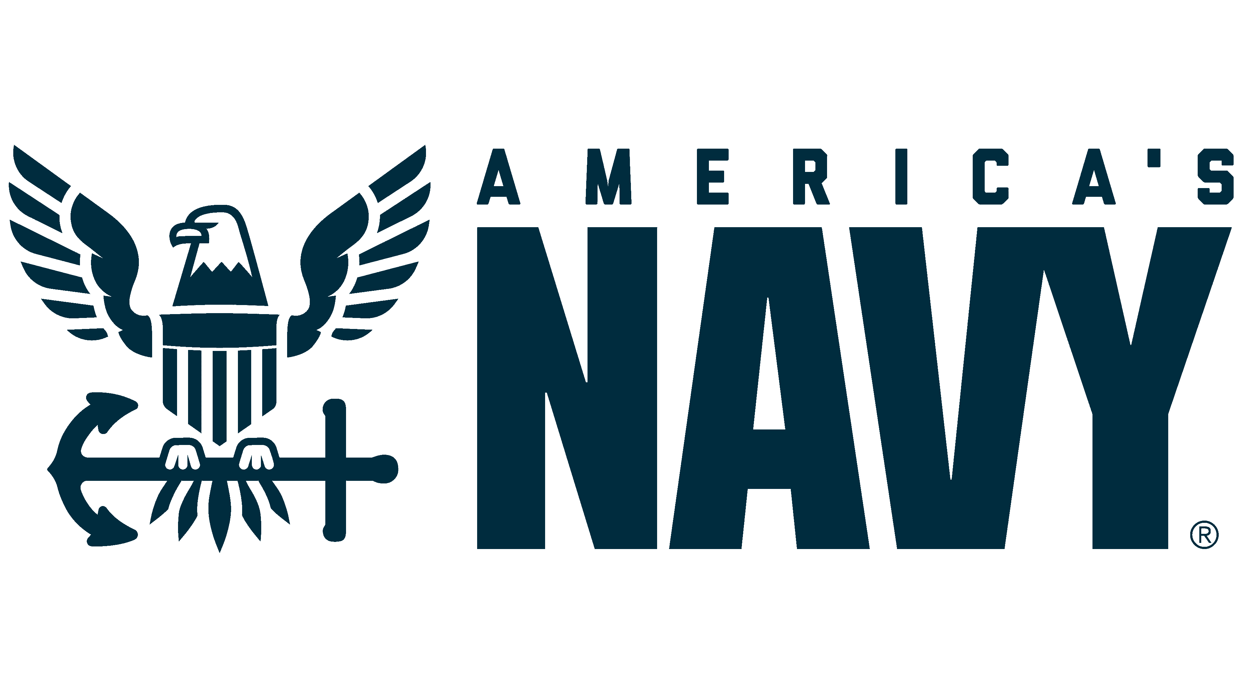
Commander XXXXX X XXXX
Supply Corps, United States Navy
Detailer, Office of Supply Corps Personnel (PERS 4412)


Commander XXXXX XXXX is a native of Millington, Tennessee. He graduated from the University of…..

Operationally, CDR XXXX served as….

Ashore, CDR XXXX….

CDR XXXX is a qualified Naval Aviation Supply Officer….

Updated: Apr 2025

