Checklist for PRD applications?
Use the following checklist to ensure your Sailors are maximizing their opportunity:
- Utilize C-WAY to identify Sailors who have entered their PRD window.

- Conduct a CDB to find out your Sailor’s intentions and document results in CIMS.

- If a Sailor is applying for conversion, ensure the CCC prints out the Job Qualification List to ensure your Sailor is applying for ratings for which they qualify. The Job Qualification List can be found under the Sailor Browser tab in the C-WAY portal.

- Ensure the CCC has input all C-WAY PRD applications for eligible Sailors. Failure to submit an application for each eligible Sailor will result in command receiving a “Failed to Submit” for the month.

- If denied a PRD quota, contact the detailer immediately for further guidance.

NOTE: Although the C-WAY system automatically generates PRD applications 15 months prior to PRD, it is the responsibility of the CCC to ensure the auto-generated applications are accurate and submitted each month.

Who is eligible for an auto-approval reenlistment quota in C-WAY?
Sailors in an “open rating” or undermanned YG will get an immediate status of APPROVED in C-WAY provided the following conditions are met:
- Sailor submits a valid application.

- Sailor applying based on system-generated SEAOS application.

- Sailor is not in a nuclear program.

- No automatically populated data on the C-WAY application has been changed (i.e. security clearance, PFA, evals, etc.). Changing data on the application will result in the application changing from “auto-approved” to “approved pending” status for ECM review.

A rating is considered “open” if it’s aggregate manning is less than 98%.

Determination of an “open rating” or undermanned YG will be continually evaluated based on current rating manning and may change during the month. Once a rating or YG is no longer considered “open”, the auto-approval status will be suspended.

Auto-approval Flow Chart
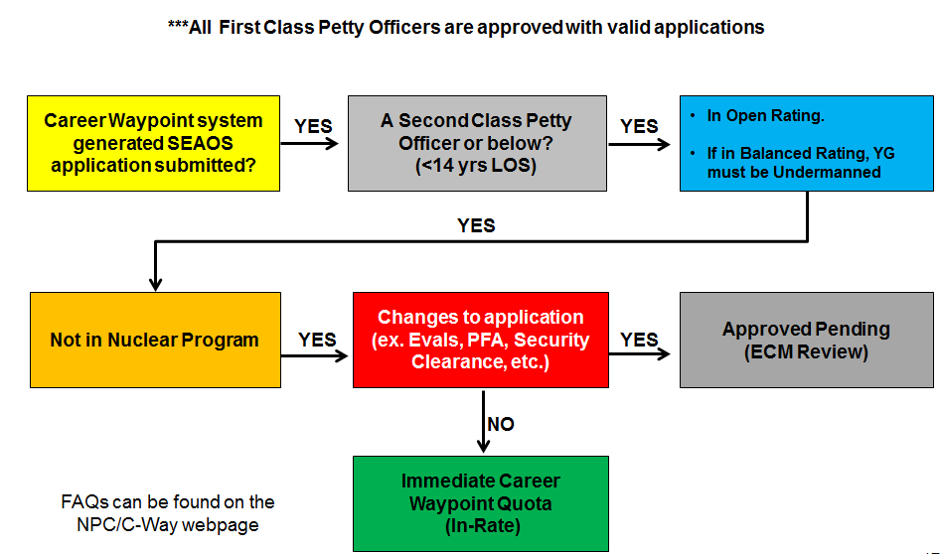

Career Waypoints PRD Timeline
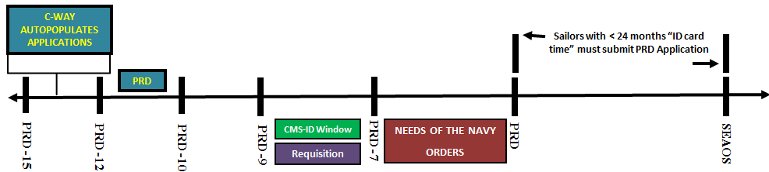

PRD applications are only processed at 12, 11, and 10 months prior to PRD. A Sailor with less than 24 months between PRD and SEAOS must submit a PRD application.

If a Sailor is denied a PRD quota, the Detailer will take one of the following actions:
- Sailor will remain in place and their PRD will be matched to their SEAOS.

- Have the Sailor execute a Short Term Extension (STE), if eligible, IAW MPM 1160-040. This option will allow the Sailor to transfer without a C-WAY quota.

- Transfer the Sailor with shorter OBLISERV.

- Transfer the Sailor with an approved Retainability Waiver.

Checklist for SEAOS applications?
Use the following checklist to ensure your Sailors are maximizing their opportunity:
- Utilize C-WAY-REEN to identify Sailors who have entered their SEAOS window.

- Conduct a CDB to find out your Sailor’s intentions and document results in CIMS.

- If a Sailor is applying for conversion, ensure the CCC prints out the Job Qualification List to ensure your Sailor is applying for ratings for which they qualify. The Job Qualification List can be found under the Sailor Browser tab in the C-WAY portal.

- Ensure the CCC has input all C-WAY-REEN applications for eligible Sailors. Failure to submit an application for each eligible Sailor will result in command receiving a “Failed to Submit” for the month.

NOTE: Although the C-WAY system automatically generates reenlistment applications 15 months prior to SEAOS, it is the responsibility of the CCC to ensure the auto-generated applications are accurate and submitted each month.

Professional Apprenticeship Career Track (PACT)
The PACT program is designed to enlist Sailors into a general apprenticeship program that provides apprentice-level formal and on-the-job training, leading to a viable career field within 2 years on board their permanent duty station (PDS).
There are three types of PACT Career Tracks:
- A-PACT: Aviation (AR, AA, AN)
- E-PACT: Engineering (FR, FA, FN)
- S-PACT: Surface (SR, SA, SN)

PACT Sailors have four designation pathways to choose from:
- “A” School
- Navy Wide Advancement Exam (NWAE) – Sailor must be TIR eligible for the rating exam.
- Direct Rating Entry (RED)
- Apprenticeship Change (AN to SN, etc.)

Under current guidance, PACT Sailors, regardless of paygrade, must have a minimum of 12 months onboard their PDS to be eligible to submit a PACT designation application. This will ensure a uniform performance evaluation period and standardize on-the-job training for all PACT Sailors.

Professional Apprenticeship Career Track (PACT)
PACT Sailor ranking in C-WAY is prioritized as follows:
- Onboard billet availability (RED only)
- Performance/promotion recommendation
- Time onboard PDS
- Paygrade
- RIDE raw score
- Proximity to expiration of contract

Checklist for PACT applications
- Are you familiar with the PACT Quota Table located on the C-WAY page of the NPC website?

- Does the Sailor have 12 months onboard their PDS?

- Does the Sailor qualify for the requested rating?

- Does the Sailor need to retake the ASVAB?

- If applying for a RED quota, is there an available billet onboard the command?

- If applying for a NWAE quota, does the Sailor meet Time in Rate (TIR) eligibility IAW BUPERSINST 1430.16?

Career Waypoints SEAOS Timeline (3-2-1)
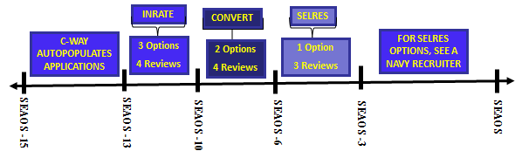

Applications are not processed until 13 months prior to the Sailor’s SEAOS.
- 13 months through 10 months prior to SEAOS a Sailor has three options: apply for an in-rate quota, conversion or SELRES.

- 9 months through 6 months prior to SEAOS a Sailor may apply for two options: conversion or SELRES.

- 5 months through 3 months prior to SEAOS a Sailor has only one option: SELRES.

What is considered “opportunity”?
Retention opportunity is defined as follows:
- For open ratings and YGs, opportunity means at least one of the following: in-rate and/or convert-in quotas.

- For balanced ratings and YGs, opportunity means at least one of the following: in-rate, convert-in and/or convert-out quotas.

- For competitive ratings and YGs, opportunity means at least one of the following: limited in-rate and/or convert-out quotas. For ratings with less than 1,200 Sailors, there may not be any in-rate quotas.

When does a Sailor apply for a C-WAY quota?
A Sailor may apply for a C-WAY quota as early as 13 months prior to SEAOS. Special Circumstance (Spec-Circ) applications can be submitted at the 12 month mark from a Sailor’s Projected Rotation Date (PRD) or EAOS, if required. Reasons to submit a Spec-Circ application include, but are not limited to, the following: SRB, decommissioning, homeport changes, LIMDU/medical status change, early transfer, Post-911 GI Bill, etc.

What happens when a Sailor returns their C-WAY quota to the ECM with the intent to separate from the Navy or refuses to OBLISERV for orders?
- The ECM will revoke the quota and the member’s C-WAY status will reflect as ITS (Intends to Separate).

- The member’s enlisted master file record will be “flagged” in accordance with MILPERSMAN 1306-125.

- If the member has sufficient contract time to meet retainability, as outlined in MILPERSMAN 1306-106, orders may be modified to complete follow-on tour assignment until EAOS/SEAOS.

What if the Sailor changes their mind and wants to “Stay Navy”?
- Sailor must submit a NAVPERS 1306/7 to his or her rating detailer, requesting removal of the record flag and stating the Sailor’s career intent.

- Detailer will forward the request to NPC’s Enlisted Distribution Division (PERS-40BB) for review.

- The Enlisted Community Manager (ECM) will review and submit recommendation.
NOTE: There is no guarantee a Sailor will be authorized to reenlist in the Navy with this request. Approval or disapproval is based off several factors; including, but not limited to: overall rating health, YG manning, Zone manning, etc.

How does NJP affect a Sailor’s opportunity to “Stay Navy”?
Consider the following when a Sailor is awarded non-judicial punishment (NJP):
- Will a reduction in rate (RIR) render the Sailor HYT?

- HYT waivers are not normally given to a Sailor who was awarded NJP.

- If awarded a Significant Problems (SP) or Progressing evaluation, does the Sailor have enough time to regain retention eligibility?

- A Sailor must receive two graded evaluations of a Promotable or higher, dated after the SP/Progressing, evaluation to regain retention eligibility.

- Once retention eligibility is regained, it is at the discretion of the ECM whether or not to reset the Sailor for an additional in-rate look.

What is a Year Group (YG)?
A YG is based on the Fiscal Year (FY) which a Sailor attended Recruit Training. Sailors will only be compared against their peers within the same YG.

How are ratings managed?
The overall goal is to equip each rating/Enlisted Manning Code (EMC) between 98% and 102% of the FY+1 Enlisted Programmed Authorization (EPA). The approach will be from the top down; overall EMC health, zone health, NEC health and finally YG health.
ECMs are authorized to compensate under-manning in a YG by overmanning within an adjacent YG. Additionally, ECMs are authorized to carry excess manning, as directed by OPNAV N132, in order to man unfunded requirements.
In order to provide retention opportunity in every EMC and retain high quality Sailors, ECMs are authorized to grant Career Waypoints-Reenlistment quotas to the top performer (determined by the “rack and stack” algorithm) each cycle. The only exception to this practice is for management of small ratings with less than 1,200 Sailors.

Why should a CPO be concerned about C-WAY?
As a Chief Petty Officer we should be very familiar with C-WAY as it affects the Sailors you lead. We should hold Career Development Boards (CDB) on all newly reported Sailors who fall in the C-WAY system. CDBs allow command leadership to have a discussion with Sailors regarding their options moving forward in their career.

How does a Sailor obtain an inrate reenlistment quota?
A Sailor’s “rack and stack” rank is dependent on the following performance indicators, in order of priority:
- CO’s recommendation for retention.

- Paygrade – Senior paygrades will rank highest in the system.

- Selected – Frocked Sailors rank higher than those not selected for advancement.

- Average of last five evaluations.

- Critical Navy Enlisted Classification (NEC) – Critical NECs rank higher than non-critical NECs.

References
To better assist your Sailors please familiarize yourself with the following resources on the NPC website:

- Enlisted Community Managers
- Community Health Slides
- ECM Contact Information

- Detailers
- CMS Interactive Detailing (CMS-ID)
- Billet Based Distribution (BBD)
- Detailer FAQs
- Contact Information

- MILPERSMAN

- Career Waypoints & Career Counselor
- C-WAY User Guide
- C-WAY FAQs
- PACT Quota Plan
- Reenlistment References
- Conversion References
- PACT References
- Other Career Counseling links and references
- Help Desk Contact Information
  - career_waypoints@navy.mil
  - 901-874-2102

ECM & Detailer Information
MILPERSMAN Articles

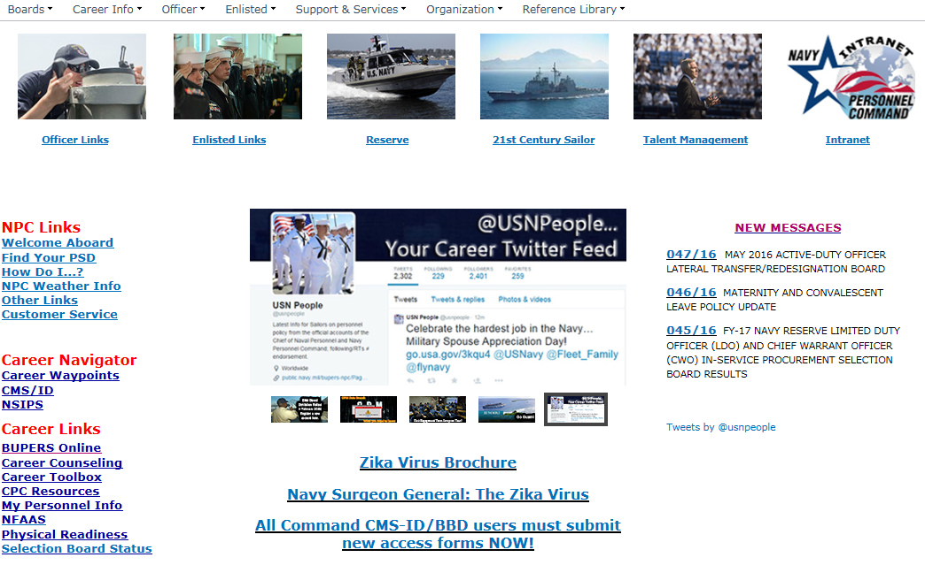
Career Waypoints & Career Counselor Information

What is Career Waypoints (C-WAY)?
Career Waypoints is a quota management and force management tool that uses performance criteria within individual ratings and Year Groups (YG) to ensure long term sustainment throughout our Navy. C-WAY provides a mechanism for matching personnel inventory to requirements with the best performing Sailors.

Who is affected by C-WAY?
C-WAY applies to all reenlistment eligible Active Component and Full Time Support Sailors E3-E6 (excluding CPO Selectees) with 14 years or less of contract time from Active Duty Service Date (ADSD) to Expiration of Active Obligated Service as Extended (SEAOS).

Why is C-WAY needed?
The Navy continually adjusts the number of Sailors needed in each rating to meet current and future mission requirements. Career Waypoints provides an opportunity to retain the best performers in each rating. C-WAY also allows Sailors to consider converting into a new rating or into the Navy Reserve as an option to remain in the Navy.

