

**NAVFIT98A**

**Frequently Asked Questions**

For

**Version 2.2.0.33**

July 28, 2025

Unclassified

Document Change History

|  |  |  |  |  |  |
| --- | --- | --- | --- | --- | --- |
| Version | Date | Drafted by | Change Type | Change Location within document | Change Description |
| **1.0** | 03/11/2025 | Kenneth Tillman | Initial Document. | All | New Software Version. |
| **1.1** | 3/24/2025 | Kenneth Tillman | Update |  | Changes following lessons Learned from V32 installations |
| **1.2** | 4/11/2025 | Kenneth Tillman | Update |  | Added the .Net Framework information |
| **1.3** | 4/30/2025 | Kenneth Tillman | Updated |  | Added 2 questions to support Part 2 in Software Center |
| **1.4** | 5/27/2025 | Kenneth Tillman | Updated |  | Updated for final v33 build dtd 5/27/2025 |
| **1.5** | 7/23/2025 | Kenneth Tillman | Updated |  | Added SR Rater Address issue and Can’t find Folder error |
| **1.6** | 7/24/2025 | Kenneth Tillman | Updated |  | Added questions about Shared Computers |
| **1.7** | 7/25/2025 | Multiple | Updated |  | Updated again for v33 |
| **1.8** | 7/28/2028 | Multiple | Updated |  | Changed misspellings and added detail for users to download/request software |

1. **How do I get NAVFIT98A ?**

***Answer:***

NAVFIT98A can be accessed or received from several locations.

* If on NMCI, “Software Center” will have the current version available for installation to a government provided computer in near future, estimate NLT 30 September 2025. Until then, NVD remains the option for NMCI users – see question on how to get the software on an NMCI Computer.
* If on Nautilus, “Company Portal” has the current version.
* If on NMCI or Nautilus, the current software can be accessed from Navy Virtual Desktop (NVD) via Remote Desktop Client (RDC) – see the question on how to access NAVFIT98A from NVD.
* If on the CANES, SUBLAN, DDG, or LCS network, the software will need to be downloaded and installed by command IT professional with appropriate administrative permissions. Command IT professionals will be able to download the installation files from My Navy Portal (NMP). Ships that are unable to access the MNP installation files shall work with their ISIC or TYCOM to acquire the files.
* If on the USMC Network, the software should be available on their version of Software Center.
* If on the USAF Network, the software should be approved (see local base ISSM) for use and may need to be requested.
* If on any other network, the software will need to be downloaded and installed by command IT professional with appropriate administrative permissions. Command IT professionals will be able to download the installation files from My Navy Portal (NMP).

1. **How do I download the NAVFIT98A Program onto my personal computer?**

***Answer:***

* NAVFIT98A is not recommended to be downloaded to a Personal Computer
* Although NAVFIT98A v30 was made available on MyNavyHr, Cyber Security concerns have prevented the software from being hosted there.
* Also, NAVY leadership is not willing to accept the risk of SSN’s being compromised on a Personally Owned computer.
* Navy has made available the NVD server for personnel to access the software

1. **How do I download the NAVFIT98A Program on my NMCI computer?**

***Answer:***

* For NMCI users, NAVFIT98A can be downloaded/installed from Software Center.

1. **How do I access NAVFIT98A through NVD?**

***Answer:***

For NMCI users, NAVFIT98A is accessible via Navy Virtual Desktop (NVD). To access NVD on an NMCI machine, complete the following steps:

* Click “Start” menu and look for “Remote Desktop”
  + If not there, Navigate to Software Center and Install
    - Click “Start”
    - Click “Microsoft Configuration Manager”
    - Click “Software Center”
    - Search for “Microsoft Remote Desktop Client” and Install
* Once installed, open the application and double click on the NVD East or NVD West

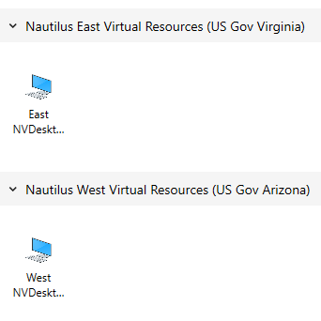

* Login to NVD using Flankspeed credentials (@us.navy.mil)

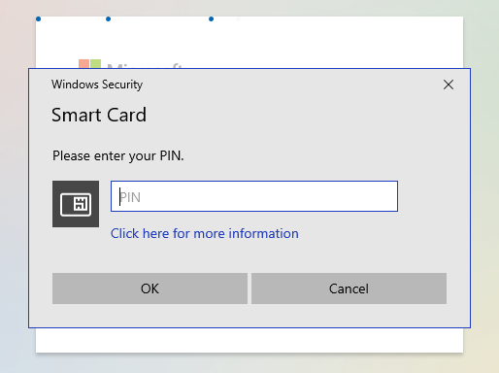

* Click the on the SEARCH block at the bottom of the screen to get the APP icons and click on the NAVFIT98A icon:

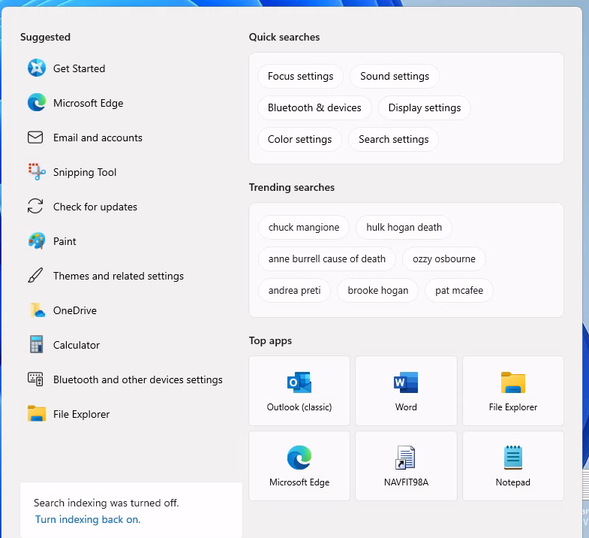

* IF NAVFIT98A is not listed -- type NAVFIT in the search block at the bottom of the screen and click Open

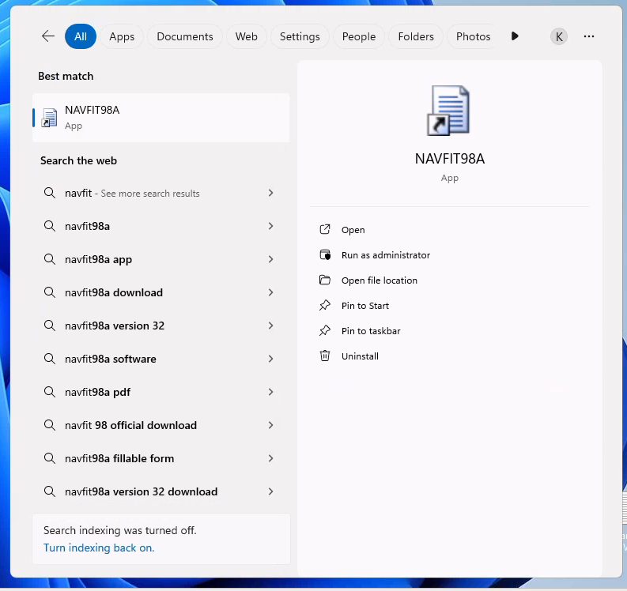

* Databases should be accessed/saved to the One Drive
* Create and draft performance evaluation IAW 1610.
* Reports can be printed as “.pdf” files, which can be emailed (following security mitigation issues) to computers with attached printers for hard copy signature.

1. **How do I download the NAVFIT98A Program on Non-NMCI, USMC, USA, USAF or other Government provided computers?**

***Answer:***

* If a member needs a Nautilus Virtual Desktop (NVD) account, they should contact their ECH II Contract Technical Representative (CTR) for a FsAST operator to request a NVD account for that member. Once the account is assigned, the member receives an email from Nautilus/NVD with instructions on how to access the NVD account.
* If you do not know who your ECH II CTR is, please see the CTR lookup information on the NMCI Information Resource portal at: https://flankspeed.sharepoint-mil.us.mcas-gov.us/sites/NAVWAR_NMCI_Homeport/NMCI_Info/SitePages/CTRResources/CTRContact.aspx

1. **How do I download the NAVFIT98A Program on Non-NMCI, USMC, USA, USAF or other Government provided computers?**

***Answer:***

* Contact the local Helpdesk. Local Helpdesks can obtain the installation files from My Navy Portal (MNP).
* The USMC is or has deployed to their MCEN server
* The AirForce is or has deployed to their AFNET server
* DHA is or has Deployed to their Health network server
* SUBLAN users will get a new system image with the newest NAVFIT98A on it.
* The installation software will be housed on My Navy Portal for download; the Documentation will be house on the My Navy HR /Career Management web site.
* If approved as a hosting site, the installation software can be retrieved from SAILOR.

1. **Which copy of the Installation package should I install?**

***Answer:***

* For centrally managed software (like Software Center) the installation software will determine which copy of the software to install.
* For manual installations, the 32bit copy of NAVFIT98A should only be installed on systems with Office 2016 or lower and the 64bit copy of NAVFIT98A should only be installed on systems with Office 2019 or higher.

1. **Right after installing the software, I get the following error:**

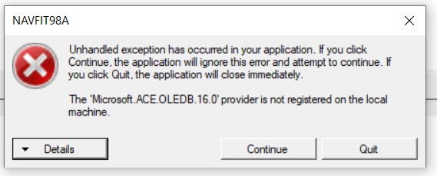

***Answer 1:***

* Open the Control Panel by searching it in the Start menu.
* In the top-right corner, select Category View, then sort it by Small or Large Icons.
* Click on Configuration Manager.
* In the Configuration Manager Properties box, go to the Actions tab.
* Click on each action listed and then select Run Now to refresh the system.
* Navigate to the Configurations tab, then select Refresh and Evaluate.
* Wait up to 24 hours, then test NAVFIT98A to determine if the issue persists.

***Answer 2 – If answer 1 doesn’t correct the problem:***

* Close all Office products
* Open the Windows Start Menu
* Click on Windows Powershell
* Right Mouse over "Windows PowerShell system" option
* Mouse over More, then click "Run as administrator"
* Paste this to the command line: start-process "C:\Program Files\Microsoft Office 15\Clientx64\Officeclicktorun.exe" -ArgumentList "scenario=repair system=x64 culture=en-us repairtype=quickrepair displaylevel=false" -wait -PassThru
* Wait several minutes then enter “exit”.
* Reboot the system.
* ***Answer 3 – If answer 2 doesn’t correct the problem:***
* Contact the MyNavyHr Help desk for a technical solution

1. **Right after installing the software, I get the following error:**

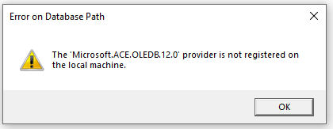

***Answer 1:***

* Verify what version of Office you are using. You may have installed the wrong bit-ness copy of NAVFIT98A
* 32 Bit NAVFIT98A for Office 2016 and 64Bit NAVFIT98A for Office 2019 and above

***Answer 2: If the error changes.***

* If the popup message changed from OLEDB.12.0 to OLEDB.16.0, see the question about what to do when receiving that message.

***Answer 3 – If answer 1 and 2 doesn’t correct the problem:***

* Contact the MyNavy Career Center at (833) 833-6622 or via e-mail at askmncc@navy.mil.

1. **Do I need to install the “NAVFIT98A Part 2 Access Database” from Software Center?**

***Answer***

* If you are not getting either of these errors when running the software or accessing a Database within NAVFIT98A, you do not need the “NAVFIT98A Part 2 Access Database” software:



* IF either of those errors popup, see the question about how to proceed when either of those errors do show up.

1. **When I install the software or run the software, a popup box shows that says “.Net Framework v4.8.1 is needed”.**

***Answer:***

* Cancel the installation or exit from the program
* This will generally occur on older shipboard and SUBLAN systems.
* In the directory where the files were downloaded from DoD Safe, find the file “NDP48-x86-x64-AllOS-ENU.exe” and run it as Administrator
* Reboot the computer

1. **Can I use an existing Database with this Version**

***Answer:***

* If the database was created with a previous copy of NAVFIT98A, it may not be used with this version. This version has a module that will convert an older database to a new format that will be compatible with this version.
* Start with an empty database created within this software version. It should only have a “Root” folder.
* The instructions to convert the database is on the NAVFIT98A menu under “Help/How to…”
* If the database was created with this version of the software, then Yes.

1. **Why** **does the printed copy and NAVFIT98A program summary group average differ?**

***Answer:***

* The calculations on the summary group average are being done in 2 places, once when the evaluation is created or changed and the second when printed. Make a change to one of the traits on the input screen to force the calculation to activate, save the information and then print the report. This should give the same information on the printed report.

1. **When I print the summary letter, I get an error “a folder must have a unique pay grade to generate a summary letter”. What is the problem?**

***Answer:***

* The user has created multiple pay grades (block 2 of the Forms) in the same folder. The user should create all the reports within a Folder to have the same Grade and this will correct the problem.

1. **The NAVFIT98A program windows are blank and the buttons are disabling on the main menu. How do I get the reports to show and the buttons on the main menu to enable?**

***Answer:***

* From the menu click “File” then “Create Database”
* The NAVFIT98A Create database prompt should appear
* Pick a location for the database and enter a name for the Database
* Click “Save”
* The ROOT folder and the buttons should appear.

1. **How do I consolidate the reports into one folder?**

***Answer:***

* A User can copy data from one folder to another by using the IMPORT Data function.
* Select the Folder (grouping) that the data needs to be copied to and press the Import Data Function
* A dialog box displays to pick a database file to import from, select the same database that is currently open.
* An Import folder dialog box displays the Folder Structure of the database showing.
* Select either the folder or all the reports under a folder and press the Import button.
* Select the folder that the reports should have been copied to view them; they will still exist in the previous folder and probably should be deleted to avoid confusion.

1. **What are the correct procedures when creating Fitness and Evaluation reports?**

***Answer:***

* Select the Root Folder
* “Click “Create Folder” from the main menu
* Assign profile name
* Click “save”
* Select newly created Folder
* Click “Create FitRep” or “Create Chief Eval” or “Create Eval”

1. **Cannot enter data in block 43 or 46. What is the problem?**

***Answer:***

* The Auto Summary check box is checked
* Click “Edit Folder”
* Click the “Option Tab”
* Unchecked “Auto Summary”

1. **How do I import or export a report with NAVFIT98A program?**

***Answer:***

* Refer to the NAVFIT98A v33 user guide manual located on the MyNavyHr Career Management webpage

1. **How can a find out what version of NAVFIT98A that I am using?**

***Answer:***

* Open the NAVFIT98A program
* Click on “Help” from the toolbar, then click “About NAVFIT98”; the version number and Build date will be displayed

1. **Why do my reports have “NOT VALIDATED” at the top if the report?**

***Answer:***

* A new requirement for this version is that the report MUST be validated before it can be sent to KOFAX for use in Promotion Boards.
* On the main screen, in the Reports sections, the last column on the right will show “True” if it was validated and “False” if it was not
* A report listed as “False” will contain the “NOT VALIDATED” message at the top.
* A report listed as “True” will not contain the “NOT VALIDATED” message at the top and will be valid for signatures and submission to KOFAX.

1. **When I print a Folder, why do some of the reports say “NOT VALIDATED” at the top and some do not?**

***Answer:***

* See the question on why “NOT VALIDATED” is on the report.

1. **My report was listed as “True”. Why does it now it says “False”?**

***Answer:***

* Every time the SAVE button is pressed, the report is changed to False, even if no changes are made.
* After saving, changes must be validated (click “Validate Report”) for the report to be identified again as “True”.

1. **When I run the “Validate Folder” option, why do none of the reports show “TRUE”?**

***Answer***

* The Validate Folder option only checks for differences between reports withing a grouping.
* The Validate Report function must be run on the individual report in order for it to be identified as “True”,

1. **I can’t get NAVFIT98A v33 on my computer; What do I do?**

***Answer***

* Blank fillable forms can be found on MyNavyHr:

[**https://www.mynavyhr.navy.mil/Career-Management/Performance-Evaluation/Software-Forms/**](https://www.mynavyhr.navy.mil/Career-Management/Performance-Evaluation/Software-Forms/)

* This is an option for Navy Personnel struggling to get the NAVFIT98A software loaded on their computer until the software can be loaded.
* This is an option for Navy Personnel stationed anywhere that NAVFIT98A is either not approved or not accessible

1. **When trying to convert a v32 file, why do I get the following Error?**

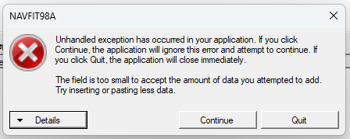

***Answer***

* The problem is that the Reporting Senior address on at least one of your reports is not formatted in the standard Address format:

Address1

Address2

City St Zip

Phone Number

DSN

* The database from v32 must be corrected using NAVFIT98A V32 or call the MYNAVYHR Help Desk for a technical solution.

1. **Right after installing NAVFIT98A v33, why did get this error when Opening the software?**

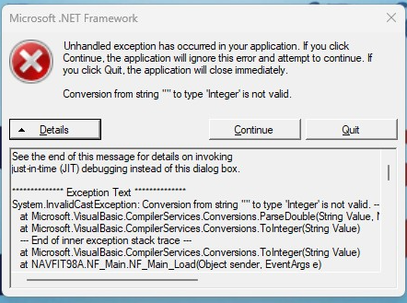

***Answer***

This occurs because a database was still open when the previous version was uninstalled and the new version installed. The settings from the previous version still exist on the system and the new version of NAVFIT can’t find the database that was open.

* Press Continue
* Select File/Exit
* Open NAVFIT98A v33 again
* The error should not occur again.
* If the error persists:
  + Press Continue
  + Select File / Create Database
  + Follow the directions for creating a database
  + Select File / Exist
  + Open NAVFIT98A v33 Again
  + The error should not occur again

1. **Are there any Known issues with NAVFIT98A V32?**

***Answer:***

There is 1 known issue with NAVFIT v33:

* The Reporting Senior Address field in V32 was a free form text field that allowed anything to be entered for an address. When the V32 database is converted to v33, that free form text Address may not be compatible with the new database structure and will throw an error rejecting the entire database. This is slated to be corrected in v34, but that version is not identified for deployment.

1. **Will this software work on a Shared Computer?**

***Answer:***

* Yes.
* As a standalone application NAVFIT98A is available to anyone logged into the computer it is installed on.
* The database being used to store the evaluations is kept in the individual user’s Remote Profile
* For NVD, NAVFIT98A is installed on the server so that when a user logs into NVD, they Virtual Desktop contains a copy of the software.
* In the case of accessing through NVD, the Database will be on the individual user’s One Drive.

1. **Is NAVFIT98A compatible with Windows 7**

***Answer:***

* No
* However, a Windows 7 compatible installation package can be requested via the MyNavy Career Center (MNCC) help desk at 1-833-330-MNCC.

1. **Summary:**

Users with NMCI assets will be able to download and install NAVFIT98A v33 from the Office 365 Software Center or can access it via Nautilus Virtual Desktop/Nautilus. Users should contact the Navy/Marine Corps Intranet helpdesk for support at 1-833-637-3669. If documentation for software is required, contact the MyNavy Career Center (MNCC) help desk at 1-833-330-MNCC. Any issues the helpdesk(s) can’t resolve will be routed for higher-level support. Joint or other service commands have been provided with instructions on how to download or access using their service-specific IT platforms.