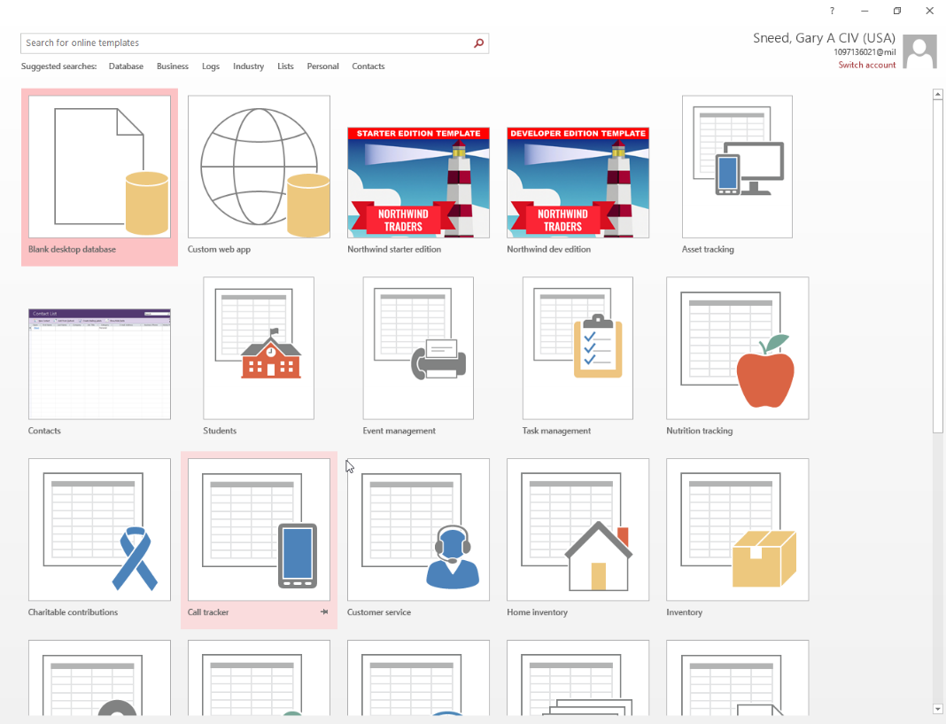**NOOCS Excel Conversion To Access**

* Open Microsoft Access
* Select Blank Database
* Select External Data tab

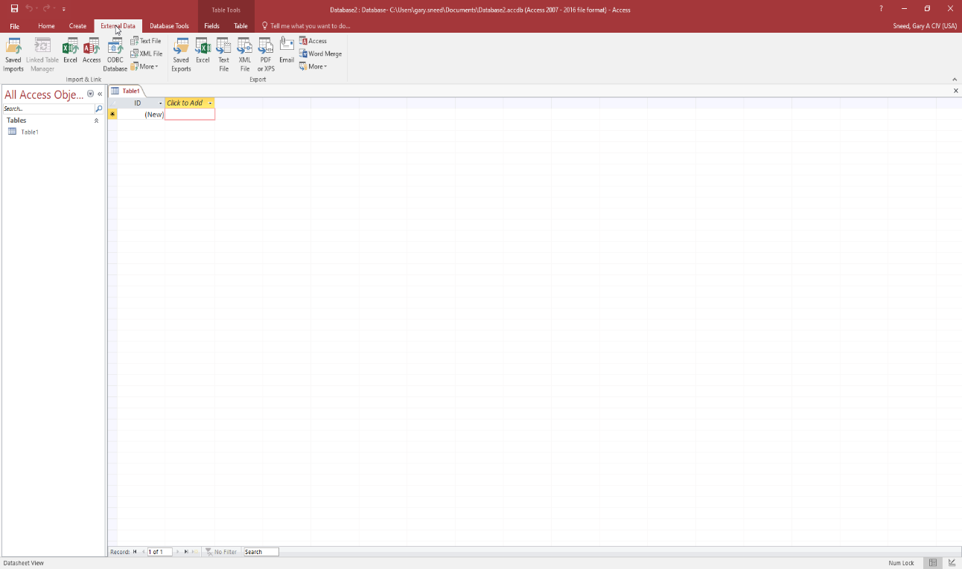

* Select Excel (to import spreadsheet)

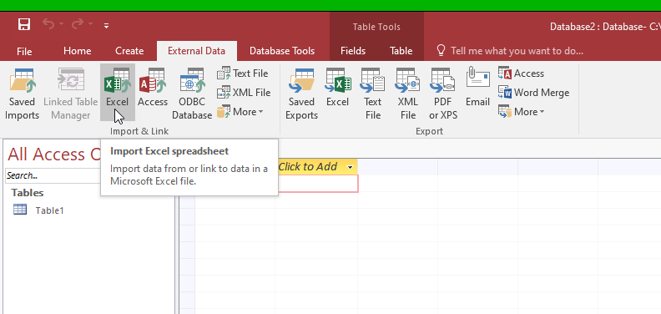

* Select NOOCS Excel file location using Browse option
* Select the appropriate spreasheet

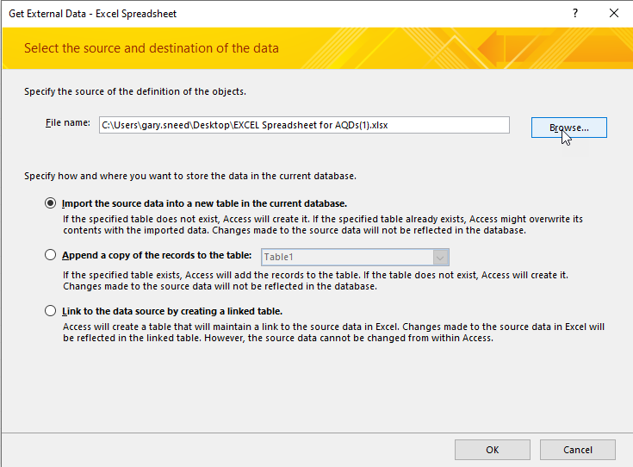

* Select “Import the source data….”
* Click OK

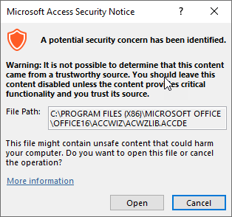

* Select Open
* Select Next

*AQD 8 AND 9 SERIES is in a different format, please select appropriate format

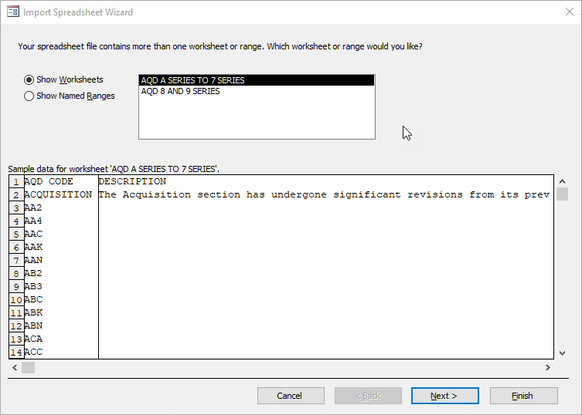

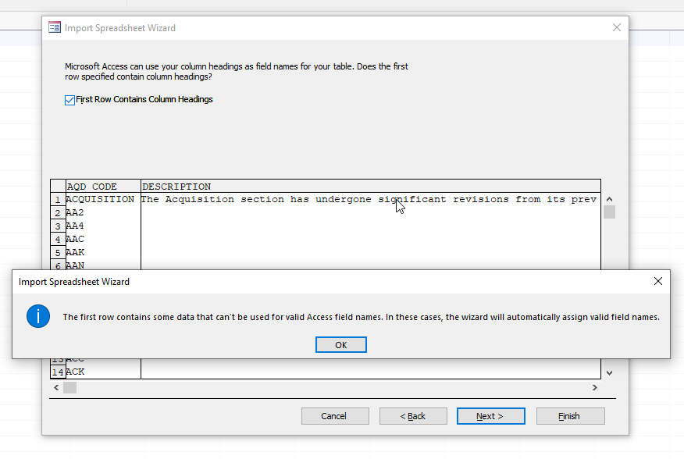

* Select “First Row Contains Column Headings” and then press “OK” to the warning
* 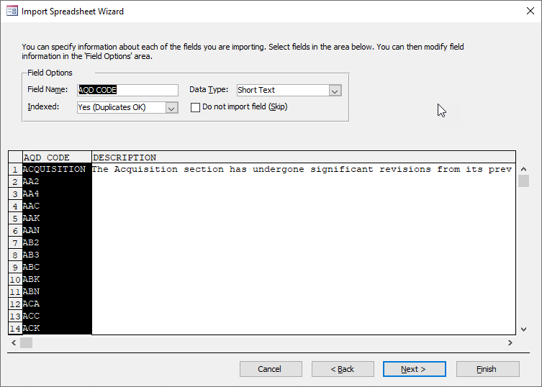Select “Next”
* Select “Next”

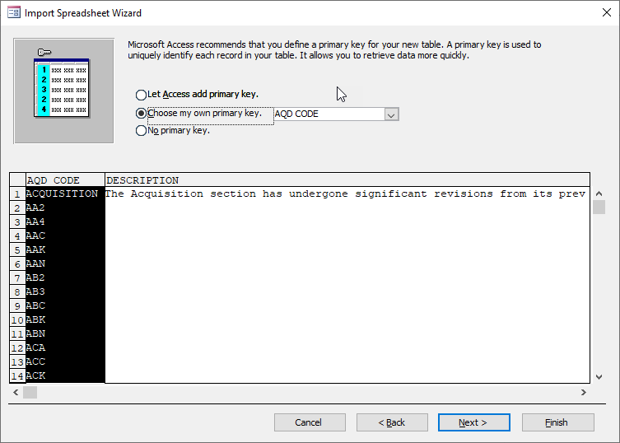

* Choose AQD CODE to be the primary key
* Select Next

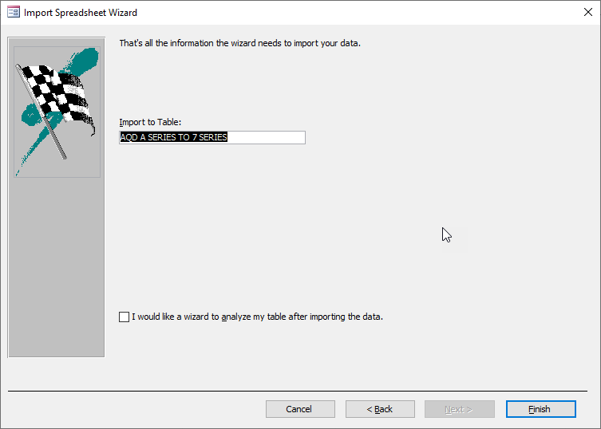

* Select Finish

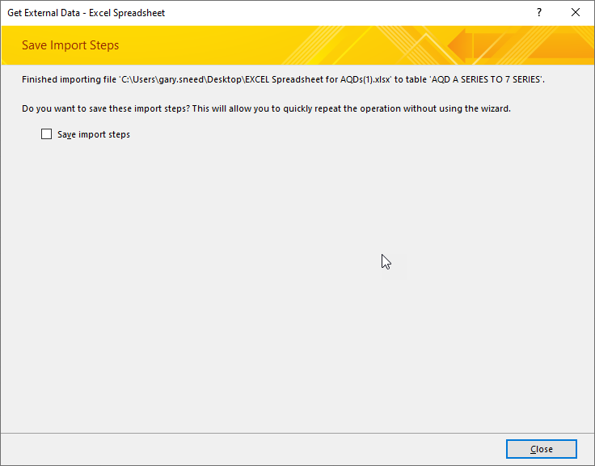

* 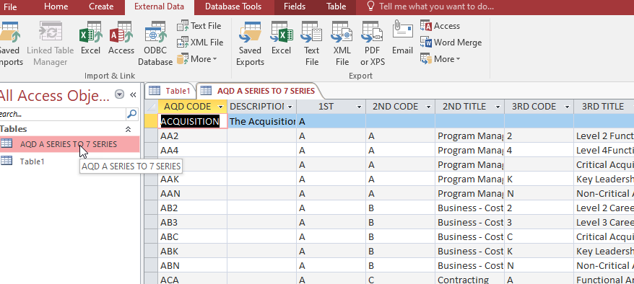Click Close
* Select “AQD A SERIES TO 7 SERIES” in the Tables section to show the imported data
* Click “File” in the top ribbon
* Choose “Save As” to save the database to a location of your choice