To download a new DD Form 2875.
Use the Google Chrome browser (preferred)
Select link below:
https://www.esd.whs.mil/Directives/forms/dd2500_2999/DD2875/
Select the Form Number: DD 2875
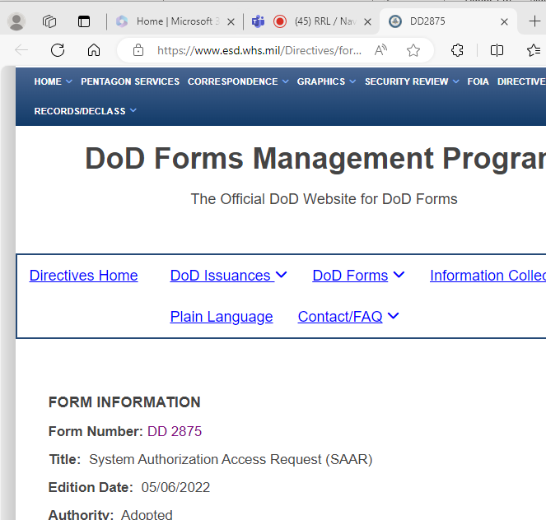
Then Save as – to a location easily accessible (i.e. your Desktop)
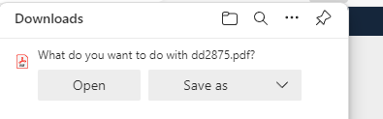
Open with Adobe Acrobat Reader.

