eUCFR



Account Request/SAAR Process

June 2024

DD Form 2875 (SAAR) Instructions

**Overview**

The DD2875 SAAR is required to obtain access to the Advana platform. All users should submit their **completed** DD2875 to the service desk the first time they are requesting access to anything on the Advana platform. Instructions on how to submit an access request ticket are documented in the [Advana Service Desk User Guide](https://wiki.advana.data.mil/display/SDKB/Advana+Service+Desk+User+Guide). Instructions on how to complete the DD2875 are explained below.

**Part I - Administrative Data** includes administrative data from the user requesting Advana access:

**Type of Request**: Use dropdown and select INITIAL.

**USER ID**: 10 Digit DOD ID (can be found on the back of your Common Access Card (CAC)

**Date**: Date of request (DDMMMYY) (use dropdown to ensure proper format)

**System Name**: ADVANA

**Location**: AWS – USMC, Kansas City

**Block 1. Name**: The last name, first name, and middle initial of the user. (same as displayed on CAC)

**Block 2.** **Organization**: The user's current organization Include Command’s Name/UIC

**Block 3**. **Office Symbol/Department**: The office symbol within the current organization (i.e. DOD).

**Block 4**. **Telephone Number/DSN**: The Defense Switching Network (DSN) phone number of the user. If DSN is unavailable, indicate commercial number.

**Block 5**. **Official E-mail Address**: The user's official e-mail address. (************@us.navy.mil)

**Block 6**. **Job Title/Grade/Rank**: The civilian job title (Example: Pay Clerk, GS-5)/military rank (PO2, United States Navy) or "CONT" if user is a contractor.

**Block 7**. **Official Mailing Address**: The user's official mailing address.

**Block 8**. **Citizenship**: (US, Foreign National, or Other).

|  |
| --- |
| Foreign Nationals must submit a memo waiver to the Service Desk. Click [here](https://wiki.advana.data.mil/display/SDKB/Guidance+on+Foreign+National+Citizenship+Waivers) for guidance on Foreign National Citizenship Waivers. |

**Block 9**. **Designation of Person**: (Military, Civilian, Contractor).

*Contractors will be required to submit their contract number in box 16a.

**Block 10**. **IA Training and Awareness Certification Requirements**: User must select that he/she has completed the Annual Information Awareness (Cyber Awareness) and the date. The completion date must be current within 1 year of being signed by all parties.

**Block 11**. **User's Signature**: User must sign the DD Form 2875 with the understanding that they are responsible and accountable for their password and access to the system(s). The signature must be digitally signed with a DoD issued CAC. Invalid/wet signatures will not be accepted.

**Block 12**. **Date**: The date that the user signs the form.

**Part II - Supervisory Endorsement of Access** encompasses the endorsement and justification for the user requesting access. **It requires the endorsement and digital signature of the user's supervisor.**

|  |
| --- |
| Please note that block 18a and 19b of the SAAR must remain unsigned. These blocks are completed by an Advana staff member. If invalid signatures are found in these fields the SAAR will be rejected by the Service Desk. |

**Block 13**. **Justification for Access**: A brief statement is required to justify establishment of an initial USER ID. Provide appropriate information if the USER ID or access to the current USER ID is modified. “Require access to monitor Navy DJMS UCFR.”

**Block 14. Type of Access Required**: Place an "X" in the appropriate box.

Authorized - Individual with normal access.

Privileged - Those with privilege to amend or change system configuration, parameters, or settings.

**Block 15. User Requires Access To**: Place an "X" in the appropriate box.

Unclassified - Individual requesting access to Advana on NIPR

Classified - Individual requesting access to Advana on SIPR

**Block 16. Mark the Checkbox for the Verification of Need to Know**: To verify that the user requires access as requested.

**Block 16a. Expiration Date for Access**: Contractors must enter their contract # and expiration date in this field. If the user is CIV or MIL please mark N/A.

**Block 17. Supervisor's Name**: The supervisor or representative prints his/her name to indicate that the above information has been verified and that access is required.

**Block 17a. Supervisor's Email**: Email address of the supervisor who signs the form.

**Block 17b.** **Supervisor's Phone Number**: Phone number of the who supervisor signs the form.

**Block 17c. Supervisor's Organization/Department**: Supervisor's organization and department.

**Block 17.d Supervisor's Signature**: Supervisor's signature is required by the endorser or his/her representative. The signature must be digitally signed with a DoD issued CAC. Invalid/wet signatures will not be accepted.

**Block 17e. Date**: Date of when the supervisor signs the form.

**Block 18 & 18a. Signature of Information Owner**: Signature of the functional appointee responsible for approving access to the system being requested. This block is left blank. If this block is completed it the SAAR will be rejected by the Service Desk.

**Block 19 & 19a** no longer needs to be signed by Agency gatekeepers for NFR Database access.

**PART III. Certification of Background Investigation** is completed by the user's security officer. The purpose of this portion of the SAAR is the to verify and certify the user's background investigation information. **It requires the digital signature of the user's security officer.**

# 22. Type of Investigation: The user's last type of background investigation (i.e., NAC, NACI, or SSBI). If none, enter "NONE."

# 22a. Date of Investigation: Date of last investigation.

# 22b. Continuous Evaluation Enrollment Date: Date of CE enrollment. Leave blank if user is not enrolled in CE.

# 22c. Access Level The access level granted to the user by the sponsoring agency/service (i.e. Secret, Top Secret, etc.). Access level refers to the access determination made on the basis of the user's individual need for access to classified information to perform official duties; a determination separate from the user's eligibility determination.

# 23. Verified By: The Security Manager or representative prints his/her name to indicate that the above clearance and investigation information has been verified.

# 24. Security Manager Telephone Number: The telephone number of the Security Manager or his/her representative.

# 25. Security Manager Signature: The Security Manager or his/her representative indicates that the above clearance and investigation information has been verified. The signature must be digitally signed with a CAC. Signatures from ECA certificates are accepted. Invalid/wet signatures will not be accepted. Note: Signatures from ECA certificates are only valid for the the security manager signature.

# 26. Date: The date that the form was signed by the Security Manager or his/her representative.

# Common SAAR errors requiring correction:

* **Document not signed in correct order.**
  + **Must be signed by requestor, then supervisor, then security manager.**
  + **Do not personalize digital signature, it will result in return of SAAR.**
* **Blocks 18, 18a, 18b, 19, 19a, 19b, 19c being completed, they must be blank.**
* **Dates not in proper format (use dropdown option) (YYYYMMDD)**
* **Date in Block 12 must match date in electronic signature (Block 11)**
* **Blocks 5 or 17a not containing an official email address.**
* **Block 10 IA/Cyber Awareness training not checked or not within a year.**
* **All commercial phone number are not 10-digits ((xxx) xxx-xxxx format)**
* **Information Assurance Training not completed within year or missing.**
* **Blocks 8, 9, 10, 14, 15, and 16 not checked.**
* **Date in block 25 does not match date signed in block 24 (Block 25 should auto-fill when block 24 is signed – if not auto-filled, manually enter date; date should match signed date in block 24)**
* **Block 14a not completed by contractor or expiration date has expired.**
* **Block 16a not provided or incomplete from Contractors or contract expiration date in the past.**
* **Clearance investigation is outside the 10-year window**
* **Blocks 20, 21 missing**
* **Block 22a, Investigation Date outside 10-year window for Secret (6 for TS). Continuous Evaluation (CE) enrollment date not provided, if enrolled.**
* **Security section (Blocks 22-26) not properly filled out; security manager must refer to security systems to obtain proper information.**

**How to Request Initial Access / Standard Access to Advana**

**Purpose**

This article guides users on requesting access to the applications and tools on the Non-secure Internet Protocol Router (NIPR) and Secure Internet Protocol Router (SIPR).

**Note**

There are two main types of tickets you may submit in the Service Desk Portal:

* [**Access Request Tickets**](https://support.advana.data.mil/plugins/servlet/desk/portal/5/create/286)allow users to request access to NIPR and / or SIPR, and
* [**Help Desk Tickets**](https://support.advana.data.mil/plugins/servlet/desk/portal/5/create/113)are intended to troubleshoot an issue

The NIPR and SIPR systems are open to all employees and contractors with valid credentials.

How-To Steps

Submitting a Request for Initial / Standard Access

1. Navigate to [**https://advana.data.mil**](https://advana.data.mil/)and follow the steps on the screen to validate your your email address.
2. Once you have validated your email, navigate to the [**Service Desk Portal**](https://advana.data.mil/landing/servicedesk).
3. Select the **Access Request** button, as shown in Figure 1.

**Figure 1:** Access Request Ticket  
**Note:** In the**Raise this request on behalf of**field, your name will be listed by default. To submit the ticket on behalf of another user, select the down arrow next to your name, enter the name of the user, and select the user from the generated list.

1. You will be routed to a page to specify which type of access you will require.
2. Enter the following information, as shown in Figure 2:  
   Graphical user interface, text, application, chat or text message

   Description automatically generated  
   **Figure 2:** Access Request Types
   1. **Functional Domains:** Confirm your first name and last name are listed.
   2. **Tools and Data:** Request access to various tools for designing, developing, and testing analytics and machine learning algorithms to derive, report, and share insights.
   3. **Communities and Organizations**: Request access to curated data and analytic products on Advana for a specific community or organization.
   4. **Other Requests:**Request access to Advana on JWICS and short to medium-term projects focused on solving DoD-specific problems.
3. The General Information screen will open. Enter the following information, as shown in Figure 3:  
   Graphical user interface, application, Teams

   Description automatically generated  
   **Figure 3:** General Information Screen
   1. **Raise this on behalf of**: Enter your official DoD email address.
   2. **Designation:** Select your designation status from the dropdown (e.g., civilian, contractor, or military).
   3. **Agency:** Select your agency from the dropdown. I
   4. **Data Domain**: Select the from the groupings of DoD business/mission domain-specific product lines.
4. Select the **Advana** **product(s)**(applications and tools) that you require access to from the listed NIPR options,  or the listed SIPR options.
5. After selecting the products, select **Create** to submit your Access Request ticket.

Verifying Ticket Submission

1. After you have created the Access Request ticket, the ticket submission confirmation screen will appear as shown in Figure 6 so that you know your request has been successfully submitted. Scroll down and review fields for accuracy.  
   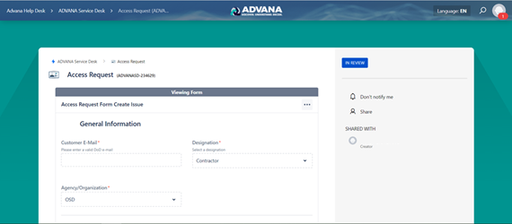  
   **Figure 6**: Top of Ticket Submission Confirmation Screen
2. Use fields on this page as needed for the following:
   1. Converse with a Service Desk Agent about any issues.
   2. Check on the status of your request.
   3. View any replies to emails (noted in Comments further down page).
3. Access this request at any time after submitting the ticket by one of the following ways:
   1. Click on the specific ticket link provided in a notification email from the Service Desk.
   2. Navigate to [**https://support.advana.data.mil/plugins/servlet/desk/portal/5**](https://support.advana.data.mil/plugins/servlet/desk/portal/5)**.**Click on the User menu icon in the upper right-hand corner. Select **My Requests** from the dropdown menu. A new screen will appear with all of your tickets listed. Click on the specific ticket you're interested in to open it.

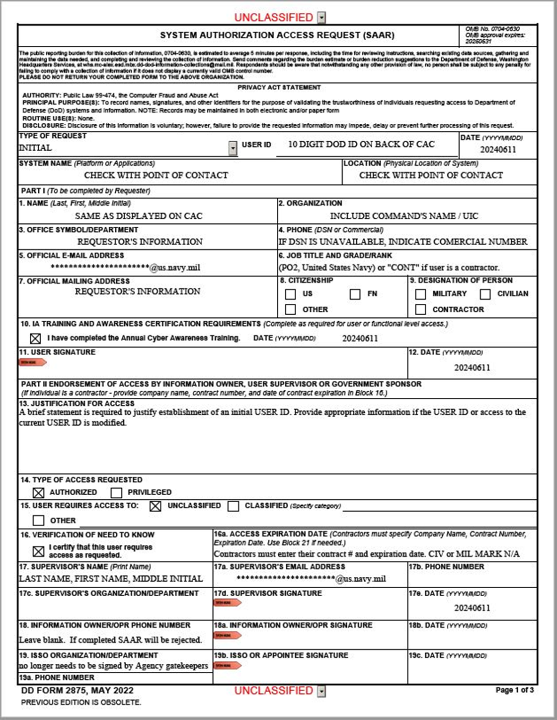

SAMPLE

SAMPLE

SAMPLE